Heuristic analysis

Runkun Miao

To have a good evaluation for isolation, it is essential to know how do we win the game when we play it. When I play the game, I like to corner my opponent or to take out my opponent’s potential move. As a result, the heuristic function has been designed in this fashion.

First of all, there are two functions that needs to be addressed, centrality and common_moves. Centrality function is to calculate the distance of opponent’s move to the centre of the board. Therefore, if the value is big, we can be sure that we are cornering our opponent. Common_moves function is to check how many moves we have in common with our opponent, which help us to chase our opponents.

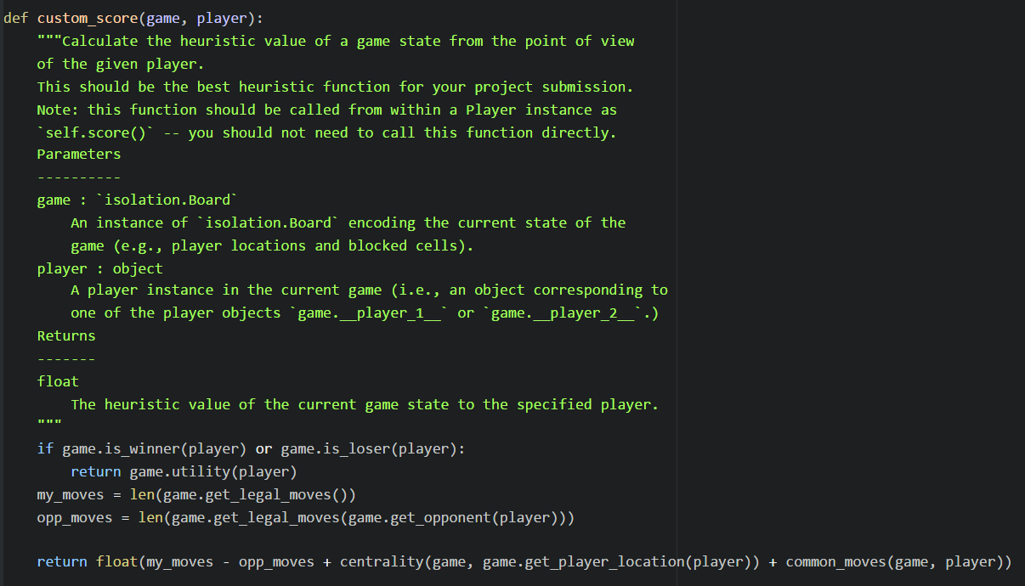

First function is straight forward, my available move – opponent’s available moves help agent to take out our opponents move, plus the centrality and common_moves which help us to chase our opponents and corner them.

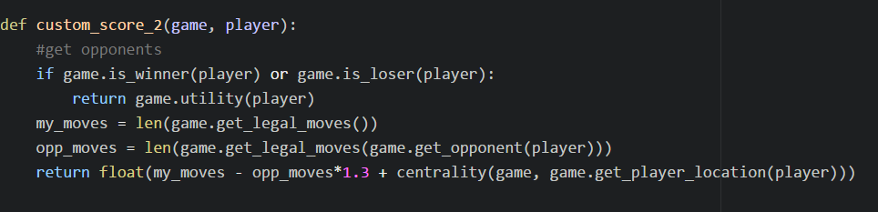

The second function is mainly focusing on cancelling out opponent’s move, opp_moves*1.3 helps our agent plays more aggressively, centrality corners our opponent.

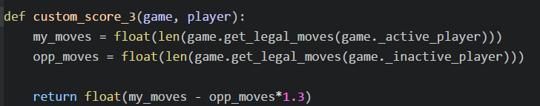

Function three is simple weighted evaluation function, which allow our agent plays aggressively.

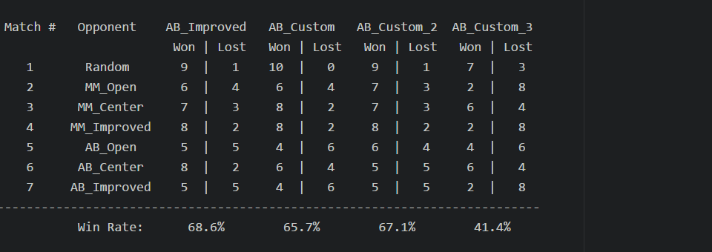

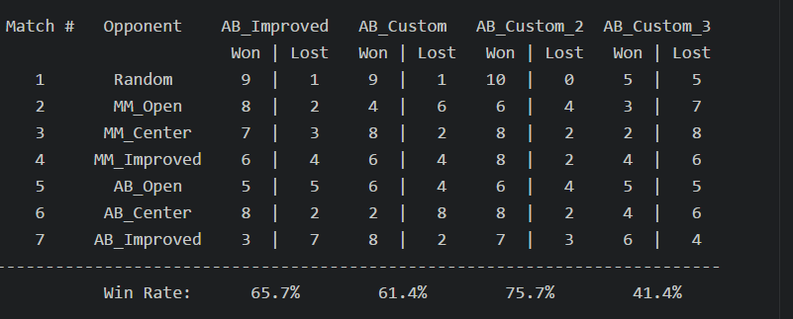

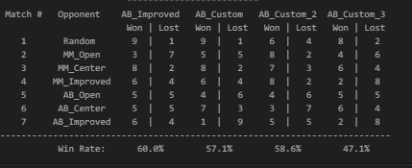

From three tests, we found out that second evaluation function has the best performance, followed by the first one. We can found out that the common_move function did not boost the winning rate as much as the simple weighted evaluation function. But the weighted evaluation function along, could not provide accurate value for agent to win the game. It might due to the fact that agent only has a short time to compute the score. Fewer variables cause evaluation function has lots of same score, if the agent does not search deep enough. In this case, agent usually makes wrong decisions.